* HTML (Hypertext Mark-up Language)
* Hypertext: - When a user clicks on this, the browser navigates to the specified URL, allowing them to access the linked resource (Link to the page).
* Mark-up: - It means Marking or highlighting Something. The HTML has Header, Body, Title, Colour, Bold etc. example of Buffalo that we are tagging them with a unique number that we can easily understand that they are how many and we have to put them in there shed according to the mark.
* There are two types of Web Pages

1. Static Web Page

Static web is a page of some fixed information that any user can access it see it read it but cannot change it (Web page cannot be changed or modify by the user it will remain same).

1. Dynamic Web Page

Dynamic Web page can change according or on the basis of user interaction. In today’s era we mostly use Dynamic Web Pages (e.g. Instagram in that we can post comment like all the stuff according to user).

* HTML (Elements, Structure, Attributes)

**Note: -** HTML elements are represented by tags enclosed in angle brackets < >.

* Structure

1. **Document Type Declaration (DOCTYPE):** Specifies the HTML version being used in this the version is 5.

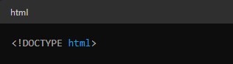

1. **HTML Element (<html>):** The root element of an HTML document.

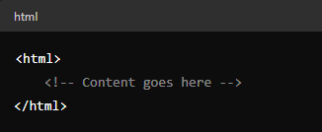

1. **Head Section (<head>):** Contains meta-information about the document, such as its title, character encoding, and links to external resources like stylesheets and scripts.

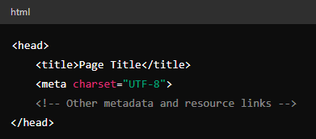

1. **Body Section (<body>):** Contains the visible content of the document, including text, images, links, and other elements.

